Name/English: ___Arive________ Date: _10th_Setp ______

Course: GS 222______ Professor: Arthur S. Abulencia

Reflection 1: IPOF and Conceptual Framework

**Learning Insights:**

**Input-process-Output :**

1. **Input:**

The group divided into three categories: individual-level factors,group-level factors and environmental factors.

1. **Processes :**

The mediating mechanisms that convert inputs to outputs.

In comparison with inputs and outputs, group processes are often more difficult to measure.

Group processes evolve over time,which means that they cannot be adequately represented through a single observation

1. **Output :**

Indicators of team effectiveness have generally been clustered into two general categories: group performance and member reactions.

**Conceptual Framework:**

**1.Definition**: explains either graphically, or in narrative form, the main things to be studied the key factors, concepts or variables

and the presumed relationship among them. by (Miles and Huberman,1994)

**2. Fit in - quantitative and qualitative** :

Quantitative: Provides the structure/content for the whole study based on literature and personal experience

Qualitative: A critical and evaluative review of the thoughts and experiences of others.Researchers generally have some idea of what will feature in the study, a tentative rudimentary conceptual framework, and it is better to have some idea of what you are looking for/at even if that idea changes over time. This is particularly true for inexperienced and/or time constrained researchers.

**3.Development of Conceptual Framework:**

1.Inputs go into developing a conceptual framework:

Experiential knowledge of student and supervisor:

Technical knowledge.

Research background.

Personal experience.

Data (particularly for qualitative).

Literature review:

Prior ‘related’ theory – concepts and relationships that are used to represent the world, what is happening and why.

Prior ‘related’ research – how people have tackled ‘similar’ problems and what they have learned.

Other theory and research - approaches, lines of investigation and theory that are not obviously relevant/previously used.

**4.Presentation of Conceptual Framework:**

1. **Include**: Process frameworks

Process frameworks

Content frameworks

The possibilities include:

Flow charts.

Tree diagrams.

Shape based diagrams – triangles, concentric circles, overlapping circles.

Mind maps.

Soft systems.

1. A triangle of needs:

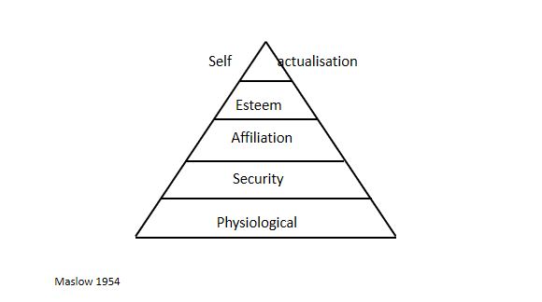

**5.The overall contribution:**

The conceptual framework encapsulates the research as it:

Sets out the focus and content.

Acts as the link between the literature, the methodology and the results (regardless of when in the PhD process it is produced).

Thus it can be/will be the focus/starting point of the evaluation of originality in terms of the criteria outlined by Hart (1998). For example:

Is what has been focussed on entirely new?

Is the way the subject been investigated different to the ‘normal’ approaches?

Has new light been shed on previously explored issues?